**Single-node MongoDB**

# Overview

1. Setup MongoDB
2. Create a data directory
3. Start MongoDB
4. Import Dataset
5. Connect to MongoDB
6. Lab Assignment

## 1. Download and install MongoDB Community Server

1.1 Go to https://www.mongodb.com/try/download/community

1.2 Download MongoDB current version (or later than 4.X) for Windows 64-bit or for other OSs.

1.3 Double click the downloaded file (.msi) and proceed the installation.

1.4 MongoDB will be installed as a service by default. However, for this lab, we will choose NOT to install it as a service by UNCHECK this box.

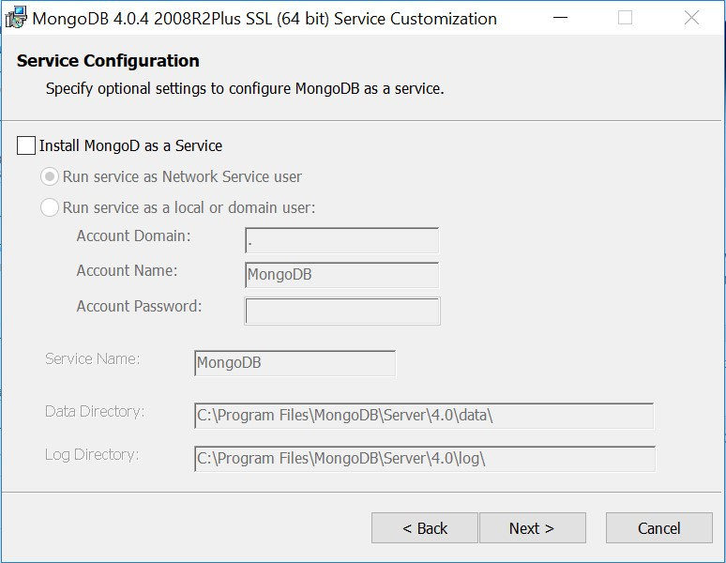

1.5 Installation of Compass is NOT necessary.

Finally, MongoDB will be installed at **C:\Program Files\MongoDB**

**2. Create a data directory with your student ID, for example, C:\u63xxxxx**

## 3. Start MongoDB

3.1 Open command prompt (Start → Run → cmd)

3.2 Run mongod.exe in the command prompt with your ID as database path (version may vary)

"C:\Program Files\MongoDB\Server\4.0\bin\mongod.exe" --dbpath "C:\u63xxxxx"

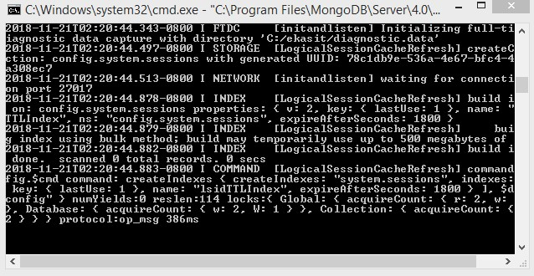

3.3 This will start MongoDB server that listens on port 27017

3.4 Leave this command-prompt window open

## 4. Import example dataset

4.1 Download the restaurant sample dataset from e-learning web site, or https://raw.githubusercontent.com/mongodb/docs-assets/primer-dataset/primerdataset.json

The following is a sample document in the restaurants collection.

|  |
| --- |
| {  "address": {  "building": "1007",  "coord": [ -73.856077, 40.848447 ],  "street": "Morris Park Ave",  "zipcode": "10462"  },  "borough": "Bronx",  "cuisine": "Bakery",  "grades": [  { "date": { "$date": 1393804800000 }, "grade": "A", "score": 2 },  { "date": { "$date": 1378857600000 }, "grade": "A", "score": 6 },  { "date": { "$date": 1358985600000 }, "grade": "A", "score": 10 },  { "date": { "$date": 1322006400000 }, "grade": "A", "score": 9 },  { "date": { "$date": 1299715200000 }, "grade": "B", "score": 14 }  ],  "name": "Morris Park Bake Shop",  "restaurant_id": "30075445" } |

4.2 Open another command prompt

4.3 Run the following command to import data. Replace “%HOMEPATH%\Downloads\primer-dataset.json” with the path where you store your downloaded dataset file. There are 25,359 documents.

(This is a single-line command)

"c:\Program Files\MongoDB\Server\4.0\bin\mongoimport.exe" --db test --collection restaurants --drop --file "%HOMEPATH%\Downloads\primerdataset.json"

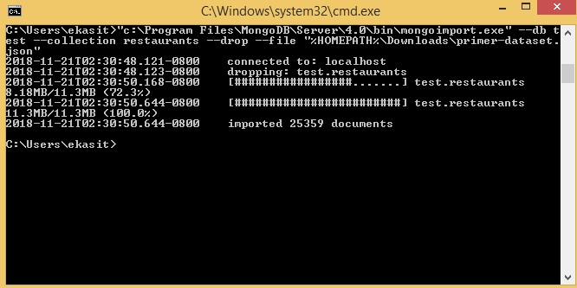

## 5. Connect to MongoDB

5.1 Run mongo.exe in the command prompt

"C:\Program Files\MongoDB\Server\4.0\bin\mongo.exe"

5.2 The mongo shell is ready to receive command

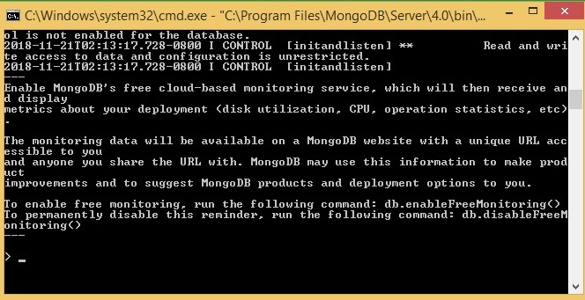

5.3 Type **use test** command to switch to use database named “test”

5.4 Query the number of documents with the following query. There should be 25,359 documents in total.

db.r

estauran

ts.count()

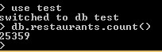

# Lab Assignment

Write the queries to:

1. Display all distinct cuisines

**Ans:** **db.restaurants.distinct("cuisine");**

1. Display only restaurant_id, name, and cuisine fields of all restaurants without the _id field

**Ans:** **db.restaurants.find({},{"restaurant_id" : 1,"name":1,"cuisine" :1,"_id":0});**

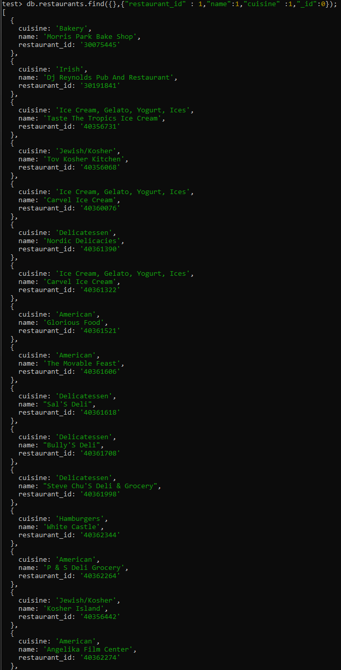

1. Find restaurants (display only name) in Manhattan (borough field equal

“Manhattan”)

**Ans:** **db.restaurants.find( {borough: "Manhattan"}, {name:1,_id:0} );**

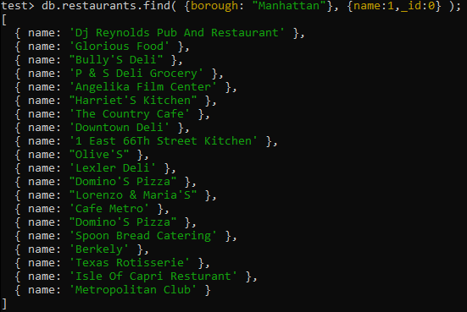

1. Find restaurants (display only name) in Manhattan which has cuisine “Bakery”

**Ans:** **db.restaurants.find( {borough: "Manhattan",cuisine:"Bakery"}, {name:1,_id:0} );**

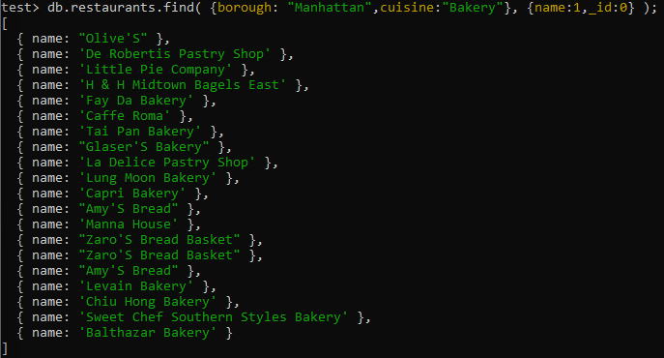

1. Find restaurants (display name and borough) in Manhattan or in Bronx

**Ans:** **db.restaurants.find({$or: [{borough: "Manhattan"}, {borough: "Bronx"}]},{name:1,borough:1,_id:0});**

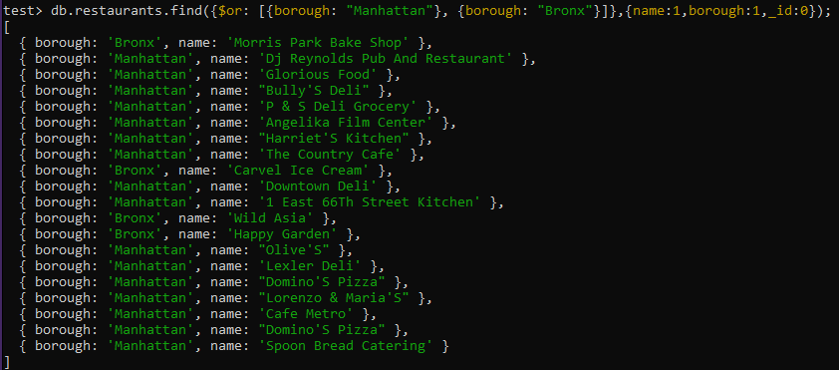

1. Find restaurants (display name, borough, and cuisine) in Manhattan or in Bronx which has cuisine “Bakery”

**Ans:** **db.restaurants.find( {cuisine:"Bakery",$or: [{borough: "Manhattan"}, {borough: "Bronx"}]},{name:1,borough:1,cuisine:1,_id:0});**

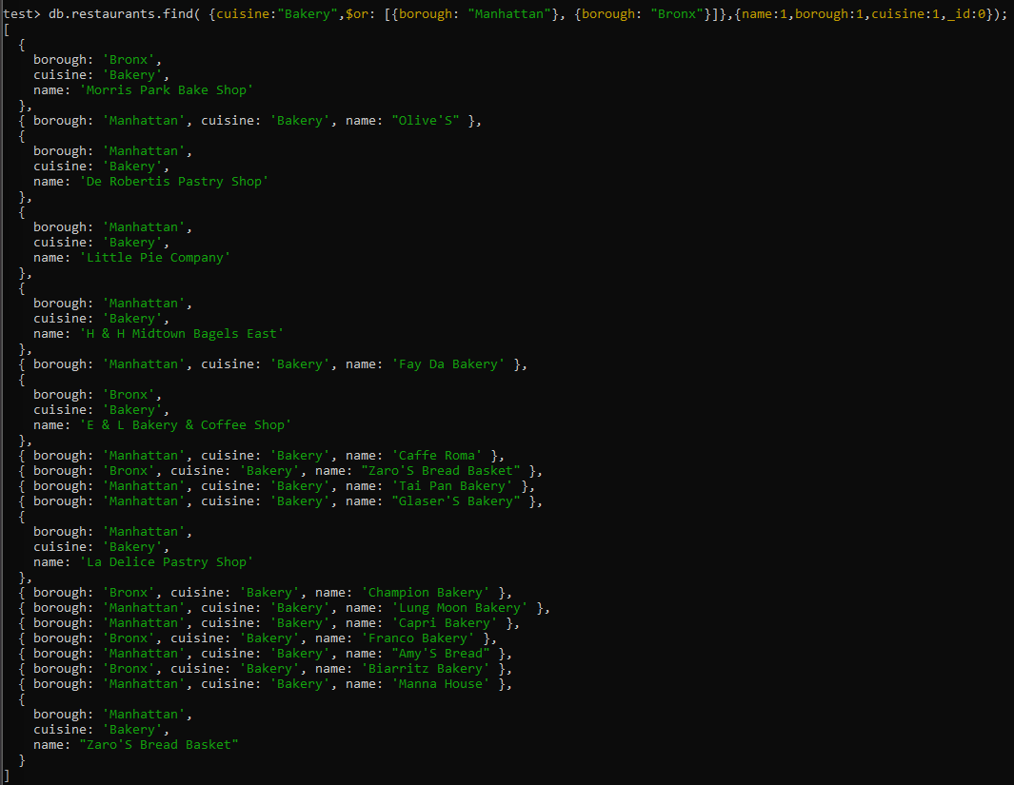

1. Find restaurants (display only name) in Bronx sorted by name in descending order

**Ans:** **db.restaurants.find( {borough: "Bronx"},{name:1,_id:0}).sort({"name":-1});**

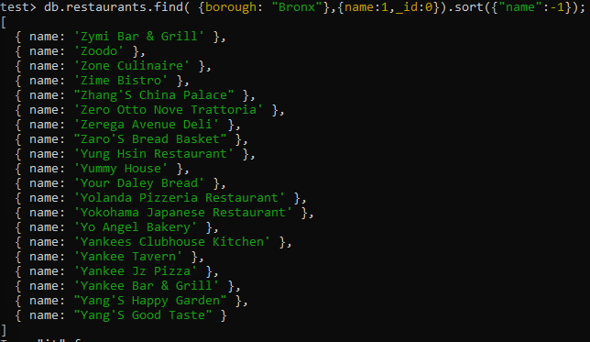

1. Find all restaurants in Bronx with zipcode 10462

**Ans:** **db.restaurants.find({$and:[{borough: "Bronx"}, {"address.zipcode":"10462"}]}).pretty();**

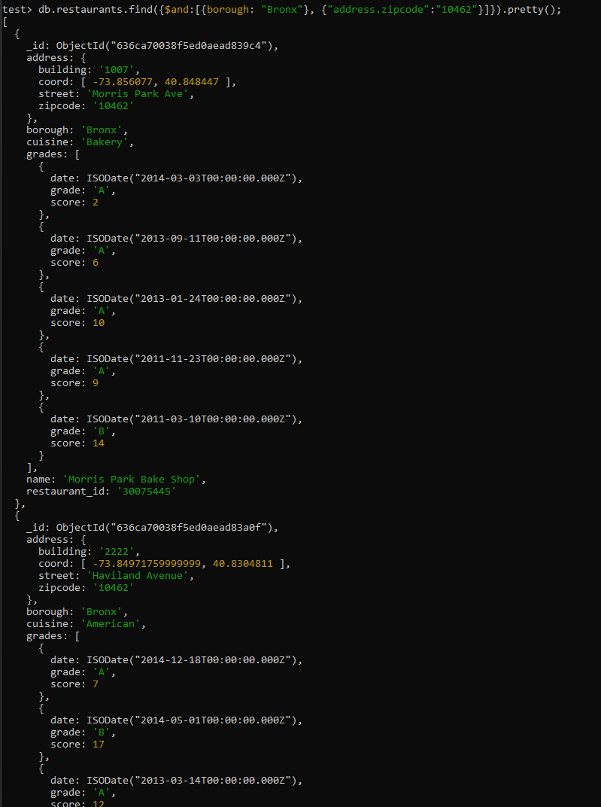

1. Describe (in English sentences) what this query returns. Do not capture output screen.

db.restaurants.find( { "grades.score": { $gt: 30 } } )

**Ans:** **Display all restaurants that have a grade greater than 30.**

1. Describe what this query returns.

db.restaurants.aggregate([

{ $match: {"cuisine": "Pizza"} },

{ $group: {

_id: "$borough", max_score: {$max: { $max: "$grades.score"}}

}}

])

**Ans:** **Display a group of all restaurants whose cuisine is pizza and group values with the borough and maximum score of this restaurant.**

Save your answers into a PDF file, and submit to the mycourse website.

**References:**

* http://www.w3resource.com/mongodb-exercises/
* https://docs.mongodb.org/getting-started/shell/query/